Understanding Projects, Boards, Statuses, and Workflows in Jira

1. Understanding Projects, Boards, Statuses, and Workflows
In Jira, work is organized and tracked using Projects, Boards, Statuses, and Workflows. Each plays a specific role in managing tasks efficiently.
1.1 Project
A Project is a container that holds:
- Issues (tasks, bugs, stories)
- Boards
- Workflows
- Reports
Example:
Online Shopping Application Development

1.2 Board
A Board is a visual representation of issues and their progress.
Types of Boards:
- Scrum Board – Sprint-based work
- Kanban Board – Continuous flow of work
Boards help teams track work visually and collaboratively.

1.3 Status
A Status shows the current state of an issue.
Common Statuses:
- To Do
- In Progress
- In Review
- Done

1.4 Workflow
A Workflow defines the sequence of statuses and transitions an issue follows from creation to completion.
Typical Workflow:
To Do → In Progress → Testing → Done

2. Customizing Your Jira Board View (Without Admin Access)
Even without admin rights, Jira allows users to personalize how they view work on boards.
What You CAN Customize
✔ Quick Filters
✔ Swimlanes
✔ Card layout (fields shown)
✔ Column view (visibility only)
✔ Board filters (personal)

Hands-On Lab 1: Use Quick Filters
- Open your Scrum/Kanban Board
- Click Quick Filters
- Select:
  - Only My Issues
  - High Priority
- Board updates instantly
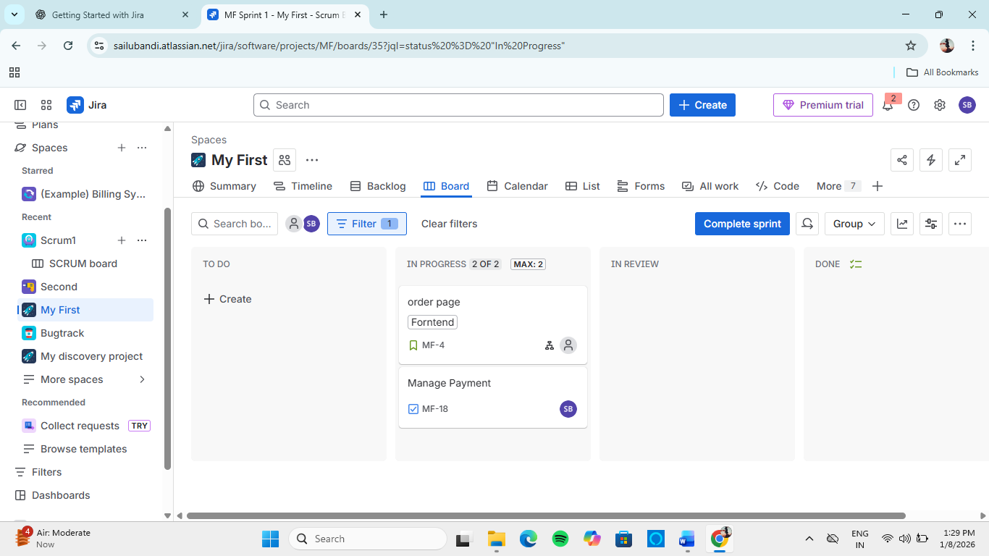

Hands-On Lab 2: Change Swimlanes
- Open board
- Click Swimlanes
- Choose:
  - By Assignee
  - By Priority
- Observe grouped issues
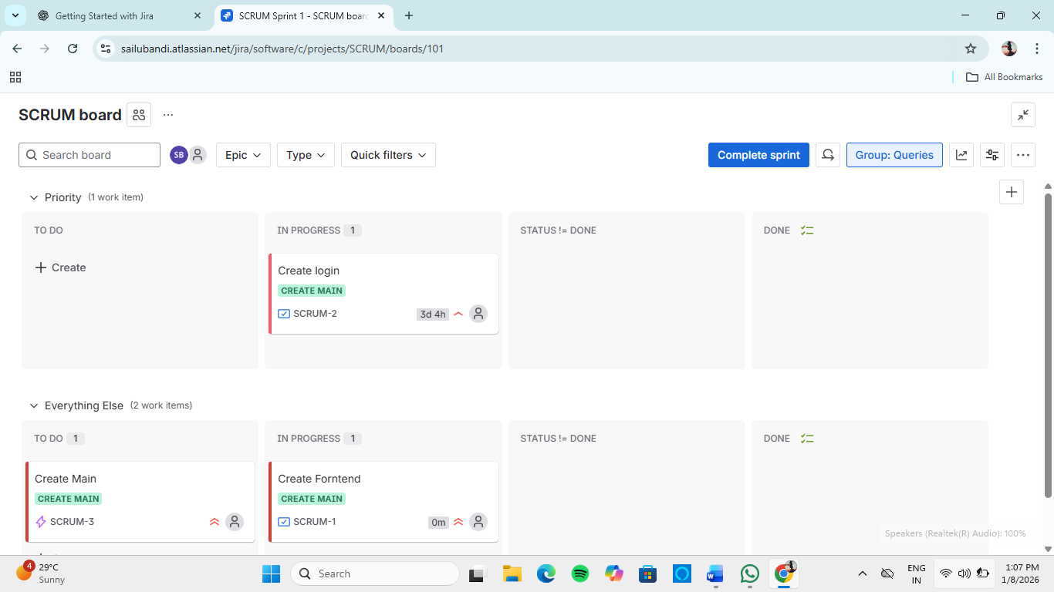

Hands-On Lab 3: Customize Card Layout
- Go to Board → Configure (⚙️) → Card Layout
- Select fields like:
  - Priority
  - Assignee
  - Story Points
- Save changes
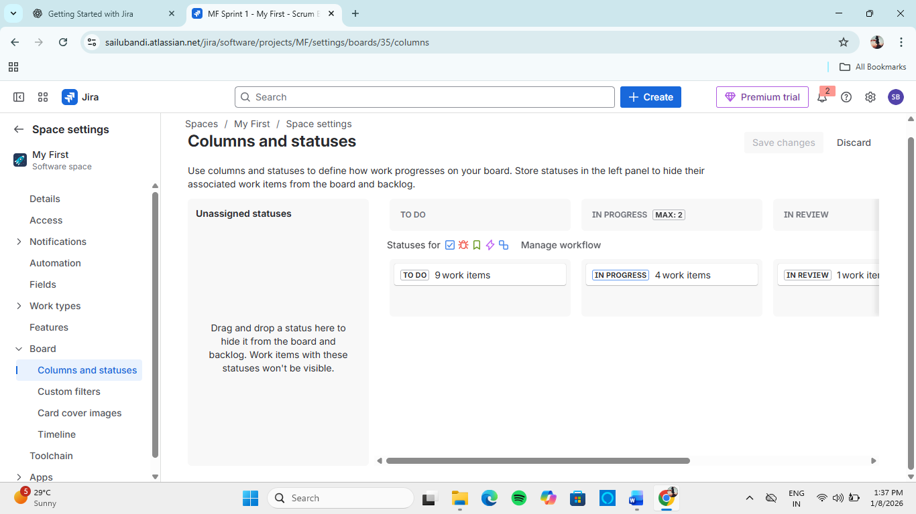

Professional Tip
Board customization improves focus and productivity without altering project configuration.

3. Workflow States and Transitions: What You Can See and Do
3.1 Workflow States
Workflow states represent where the issue currently stands.
Examples:
- Open
- In Progress
- Blocked
- Done

3.2 Transitions
Transitions are actions that move an issue from one status to another.
Example:
- Start Progress → moves issue from To Do to In Progress
- Resolve Issue → moves issue to Done

Hands-On Lab 4: Move an Issue Through Workflow
- Open an issue
- Click available Transition Button
- Change status step-by-step
- Observe workflow updates on board
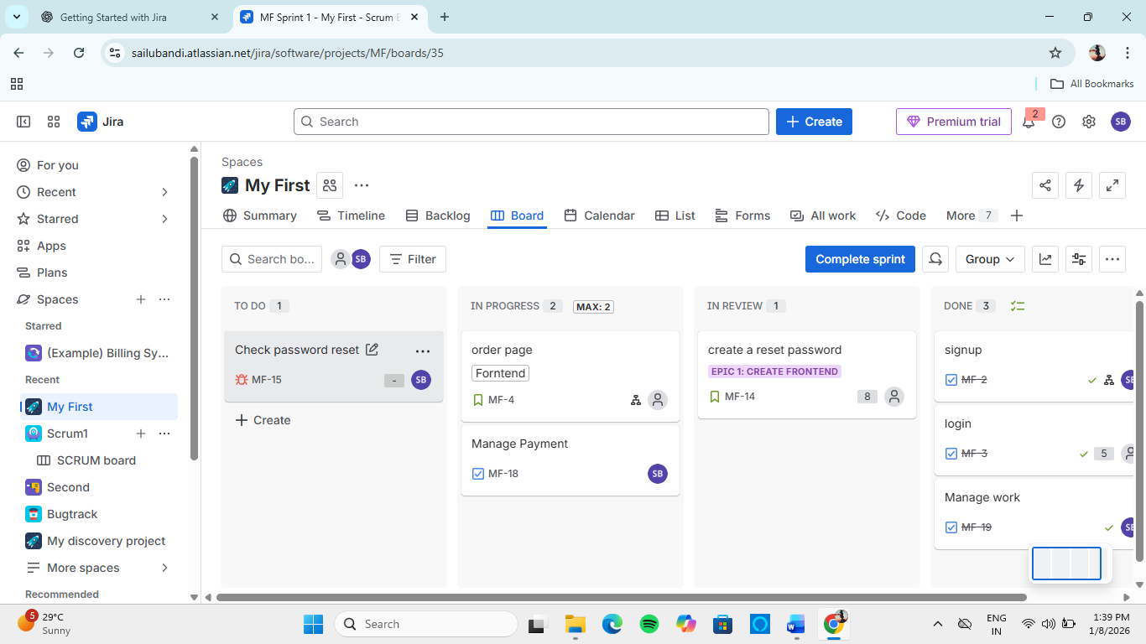

What You CAN Do (Non-Admin User)
✔ Move issues across statuses
✔ Add comments
✔ Attach files
✔ Log work time
✔ View workflow diagram

What You CANNOT Do (Without Admin Rights)
✖ Create or edit workflows
✖ Add new statuses
✖ Change transition rules

4. Viewing Workflow Diagram
- Open any issue
- Click View Workflow
- Observe:
  - All statuses
  - Allowed transitions
  - Current status highlighted
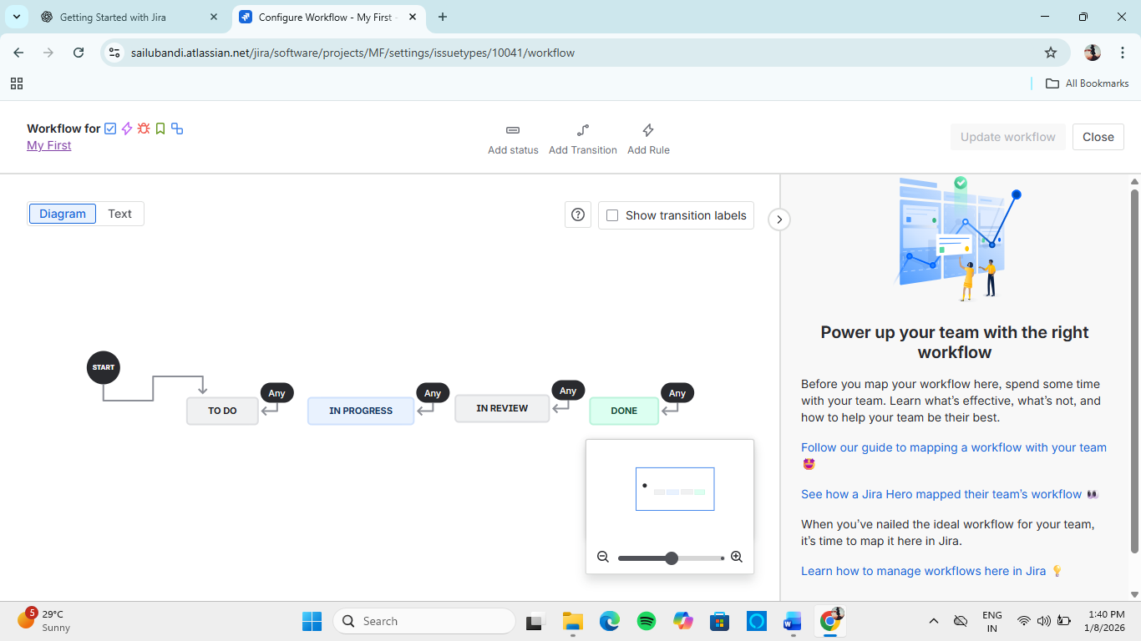

5. Best Practices
✔ Keep issues updated daily
✔ Use correct transitions
✔ Add comments for blockers
✔ Customize board for clarity
✔ Follow defined workflow strictly

6. Learning Outcomes
After completing this module, the learner can:
- Understand Jira project and board structure
- Customize board views without admin access
- Identify workflow states and transitions
- Move issues correctly through workflows

